# 3 – How to create Reseller in CyberPanel

Created On

Last Updated On

bycyberpanel

Print

* [Main](https://cyberpanel.net/docs/)
* [CyberPanel](https://cyberpanel.net/docs/category/cyberpanel/)
* [2 - Users](https://cyberpanel.net/docs/category/cyberpanel/users/)
* 3 - How to create Reseller in CyberPanel

< All Topics

If you want to have basic knowledge about users in CyberPanel please read [Managing Users.](https://cyberpanel.net/docs/1-managing-users/) Though it is already explained in [Managing Users](https://cyberpanel.net/docs/1-managing-users/) how reseller works, we will dedicate a separate tutorial for it.

There are 3 types of control lists already created in CyberPanel (admin, reseller, and user) you can also create custom control lists as well, which is not the topic of this tutorial. This post discusses reseller ACL only.

### Create a user with Reseller access

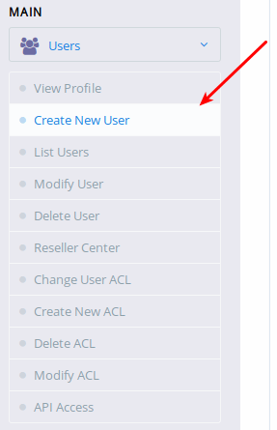

Click Create New User from the left side bar or directly go to :8090/users/createUser

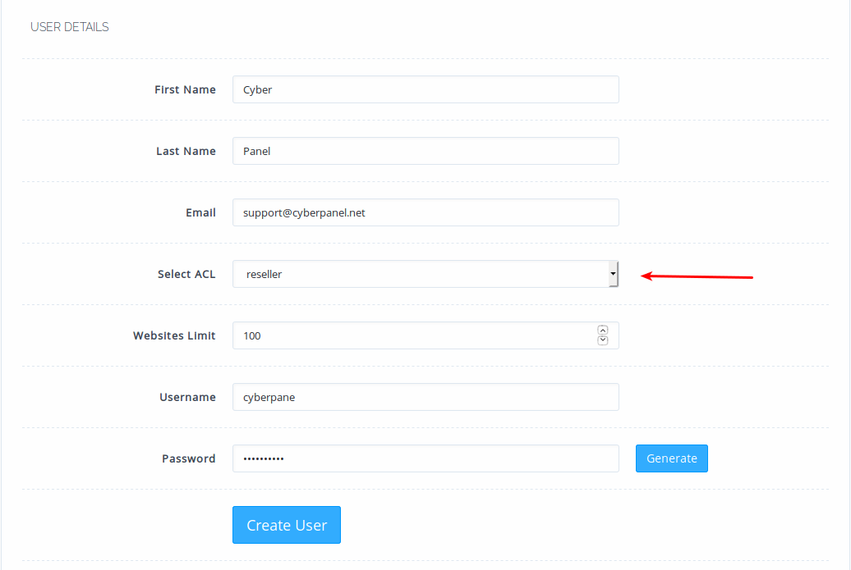

Now fill in the details as filled above, from Select ACL drop-down make sure to select reseller.

Now, what is ?

Users with reseller ACL have the ability to create websites, so admin can restrict as to how many websites they can create. Please remember this limit is not for [child-domains](https://cyberpanel.net/docs/3-creating-and-managing-child-domains/) that you can create under websites. Limits of child-domains can be controlled via Packages.

Now if there are 3 users under this reseller (reseller can also create users) and if they have 10 sites each then reseller itself can create 70 sites which then becomes a total of 100 websites.

https://cyberpanel.net/docs/3-how-to-create-reseller-in-cyberpanel/